Nama : Muchamad Rofii

NPM : 242310030

Kelas : TI-24-PA

Matkul : Desain Analisis Algoritma

Bubble Sort Descending

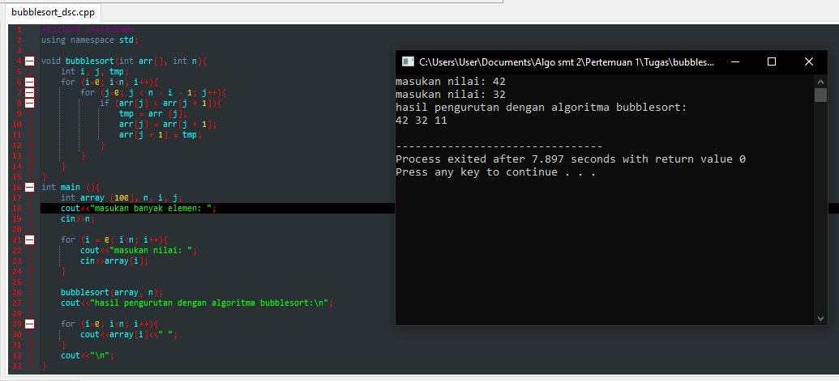

Insertion Sort Descending

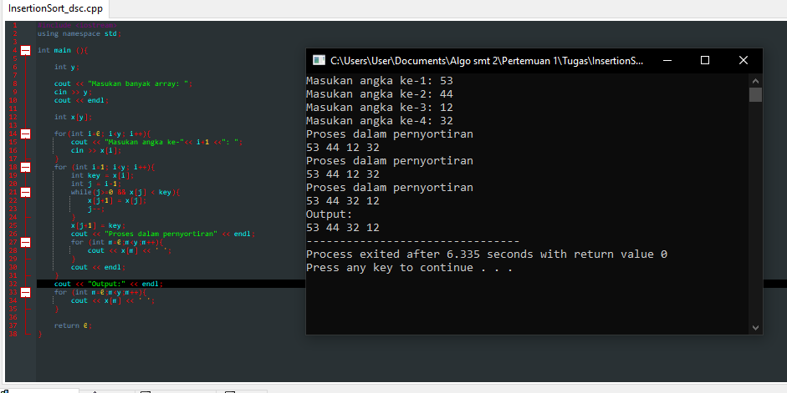

Selection Sort Descending

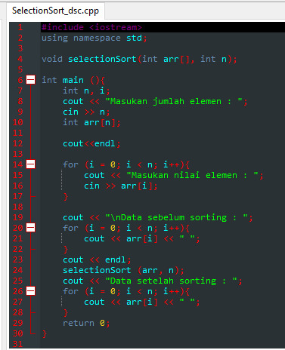

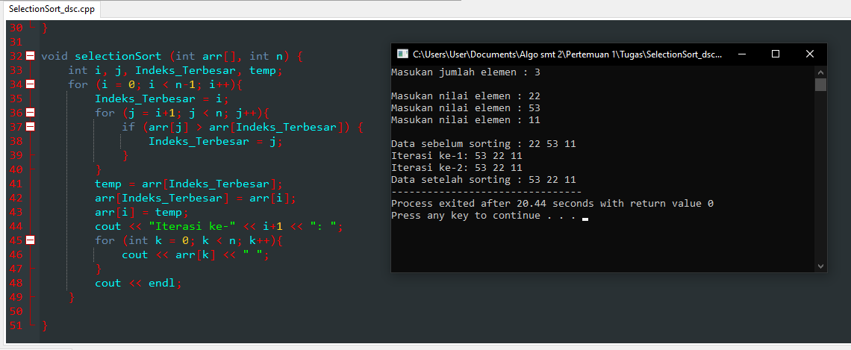

Tugas No.02 (Buku)

